# CS506 Team E Police Overtime Team Weekly Scrum Report

1. **What we accomplished this week:**
   * How have BPD paychecks changed year-over-year? Both the average amount, as compared with non-BPD Boston city employees, and the breakdown (regular pay v. overtime pay, etc.)?

**4 graphs:**

* Average BPD paycheck change year-over-year (Nurs)
* Average non-BPD paycheck change year-over-year (Nurs)
* Regular pay v. overtime pay of BPD paycheck change year-over-year (Truc)
* Analyze police total earning statistics (max, min, average, standard deviation) of police officers change over years from 2011-2022 (Truc)
* Regular pay v. overtime pay of non-BPD paycheck change year-over-year (Riva)
* Injury pay ratio to overall pay (Can)
* percentage of officers took injury pay in a given year (Can)
* Overtime earning to total earnings percentage (Riva)
* Total earnings over year (Riva)
* Overtime earning over year (Riva)
* Total police department spending by categories from 2011 to 2022 (Al)
* Average police department spending by categories from 2011 to 2022 (Al)
* Total vs Average spending by category from 2011 to 2022 (Al)

1. **Deliverable Links:**

[Links to New Project deliverables for this week, if relevant*]

*\*specify a specific page or segment for the deliverables for a given week – please make them easy to find!*

* Google collab: <https://colab.research.google.com/drive/1gVfObsV1cbzK5XpTjjA9xc1m9cBou1LY#scrollTo=zF1UGUMRS01R>
* Filtered dataset for bdp and non-bpd:

<https://drive.google.com/drive/folders/1nymOaRxWTT19KO9aepkxeFG9N_NJswKf>

* Team Google Drive:

<https://drive.google.com/drive/folders/1s5SHPEVq_ScGbUmSTzI8JXkjWZIom0p_>

**2. Individual team member updates:**

[Each team member should give a summary of their personal contributions]

***[Nurassyl Medeu]***

* Set up SCRUM report template
* Formalize the data from year 2011-2022
* Clean data for Boston police department (bpd) and non-bdp departments
* Plotted average paycheck of BPD over the years

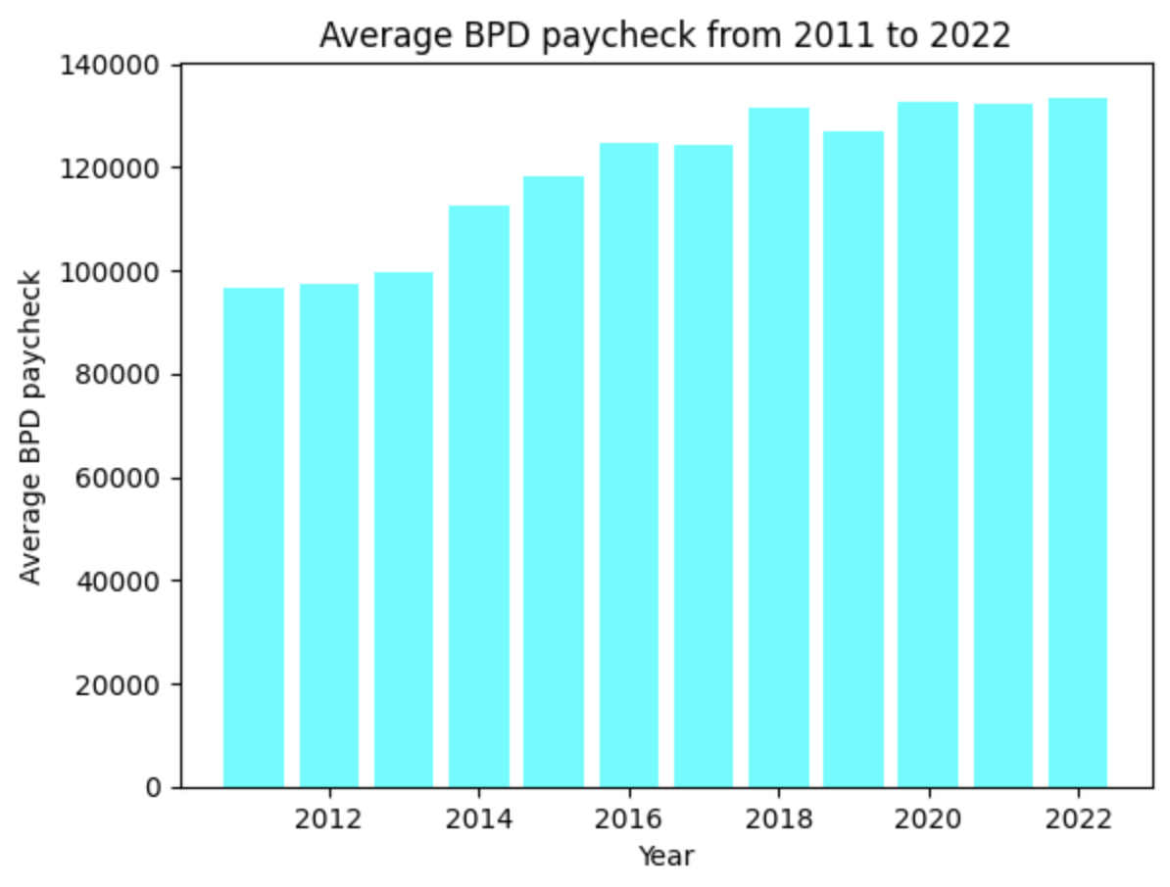

* Plotted average paycheck of non BPD over the years



***[Riva Sun]***

* Preprocessing data
* Set up helper functions assisting data cleaning
* The data from our original dataset cannot be used for computation directly.
* The number in the original dataset is in type string, with NaN, - representing null. () around the number represents negative values.
* I replaced & , - NaN and processed data into float so that it can be used for computation.
* Plotted bar chart for overtime earning for 2011-2023

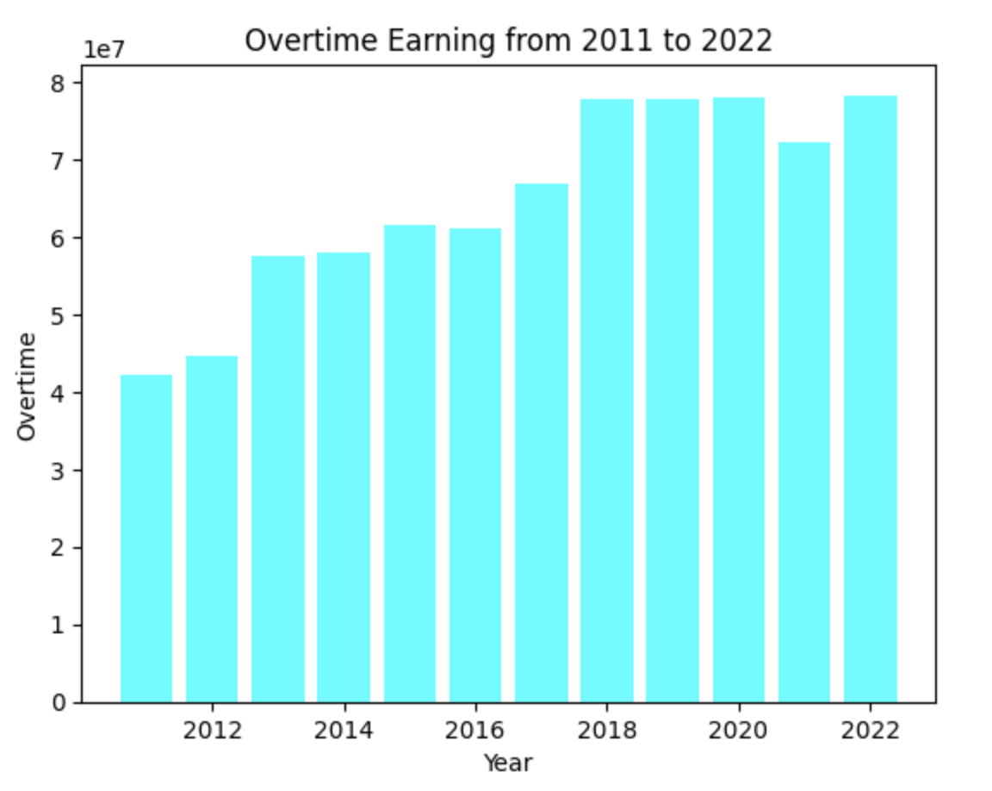

* From this chart, we can see that the overtime earning is increasing over years, and stabilized in 2018.
* Plotted bar chart for total earnings for 2011-2023

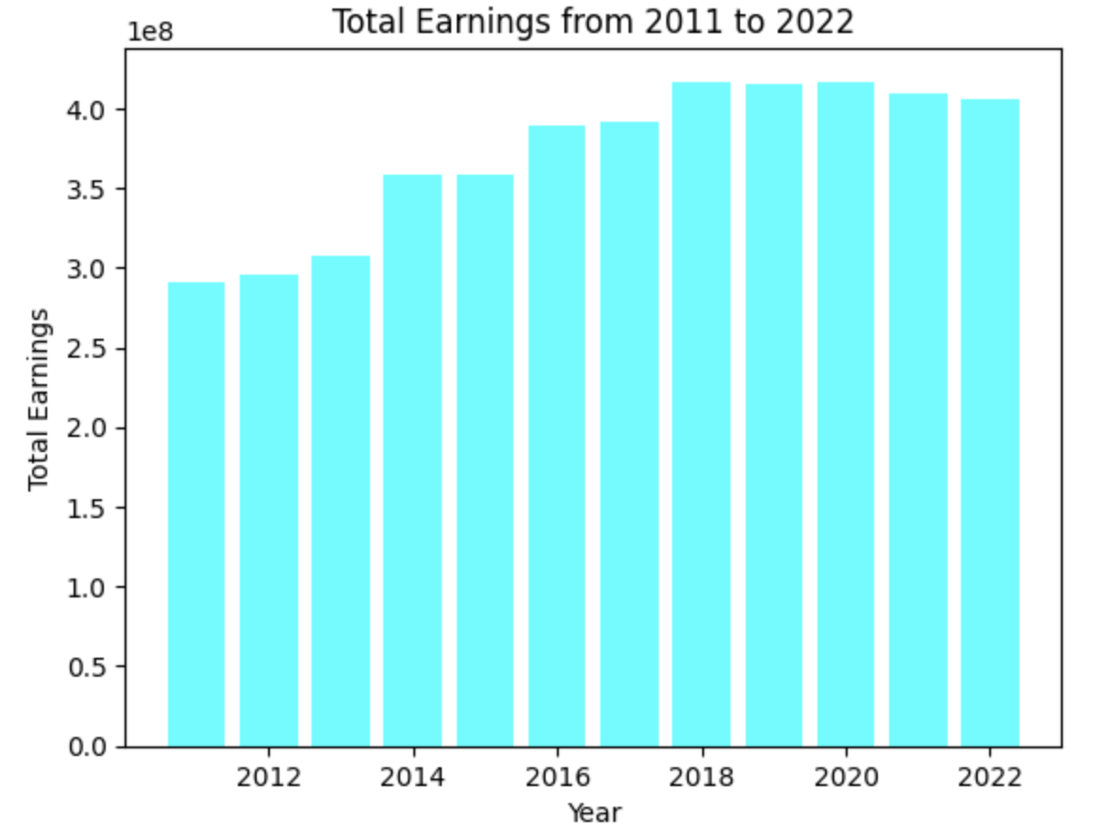

* Plotted percentage change line for 2011-2023

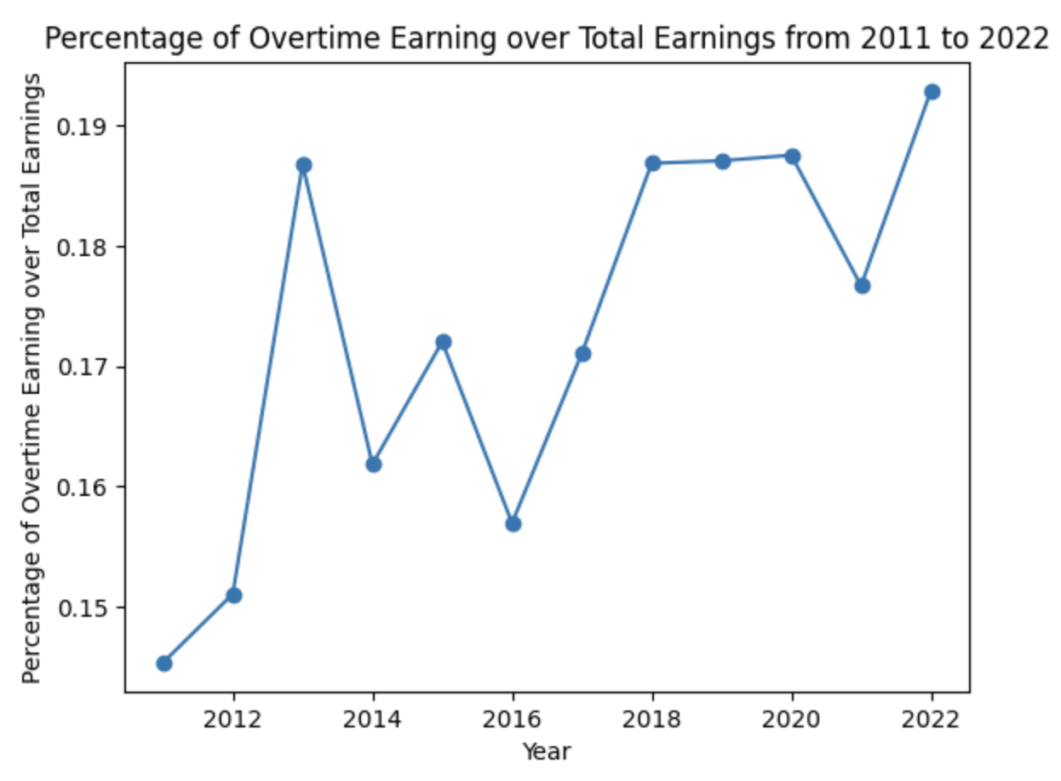

The percentage of overtime / total earnings is unstable each year, but if we observe the trend, it is increasing from 2011 to 2022. Thus, the percentage of overtime / total is increasing from the broader view.

Further analyzes will be made on the percentage of each earning out of total earnings in the next step.

***[Truc Duong]***

* Pull down raw data
* Set up google colab and import files
* Analyze Regular pay v. overtime pay of BPD paycheck change year-over-year
* Analyze police total earning statistics (max, min, average, standard deviation) of police officers change over years from 2011-2022

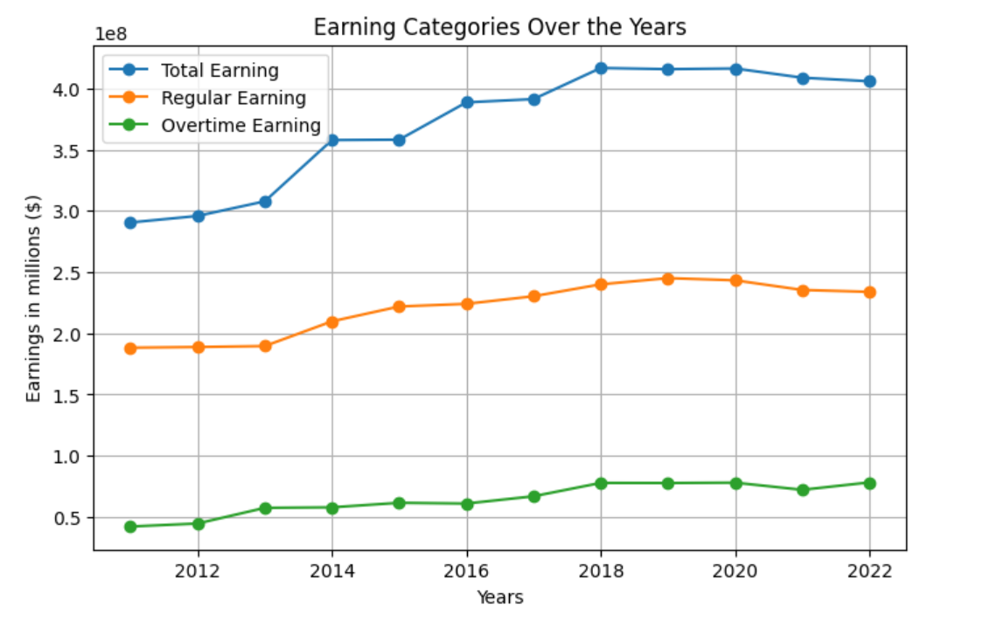

* Police total earning statistics over years:

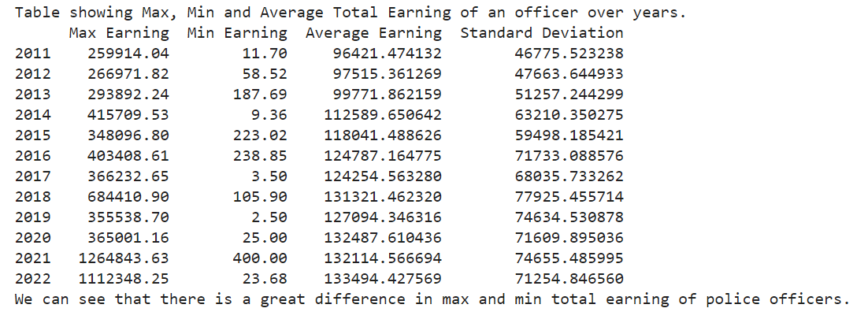

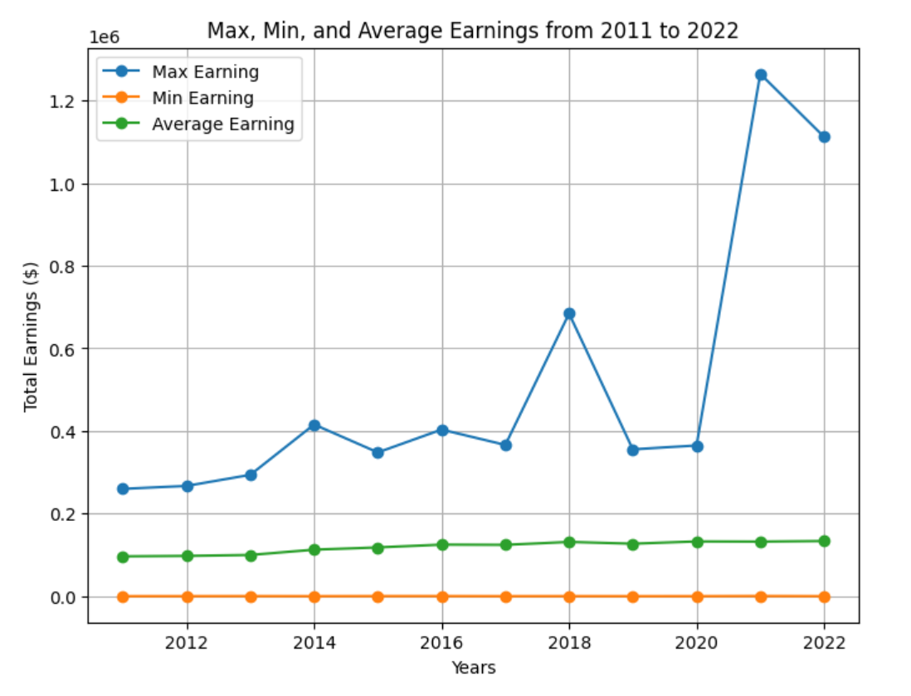

* From the graph above, we can see that the average earnings per officer grew gradually over the years.
* However, the max total earnings per officer experienced a dramatic increase from 2020 to 2022.
* Notice an abnormal increase in police earnings between 2020-2022, we looked into it and found out that the officer was actually awarded $2 million in a gender discrimination lawsuit by the Federal Jury.
* [Jury Awards Millions to BPD](https://www.bostonglobe.com/2021/11/15/metro/federal-jury-awards-boston-police-detective-2-million-gender-discrimination-lawsuit/)
* [More info on the case](https://casetext.com/case/gavin-v-city-of-boston)

***[Can Wang]***

* Analyze Injury pay ratio to overall pay
* Analyze percentage of officers took injury pay in a given year
* Plot graphs for injury payment, injury payment ratio and injury ratio
* 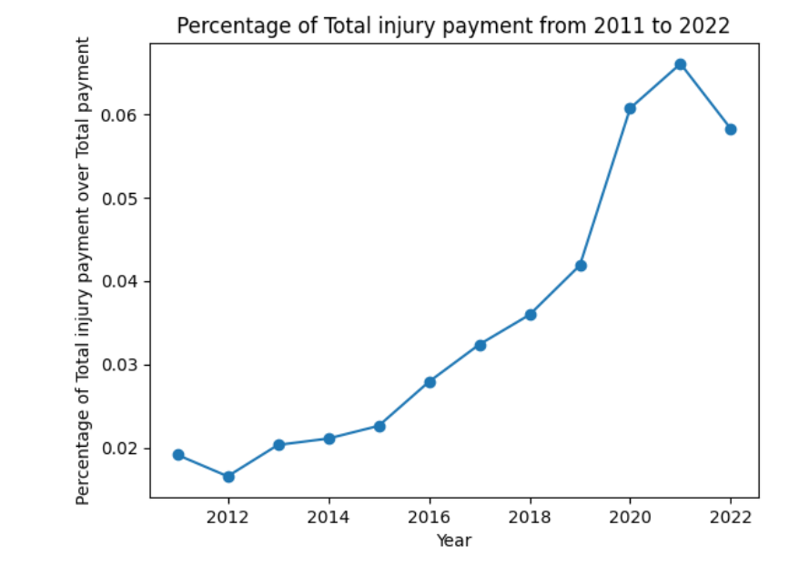
* 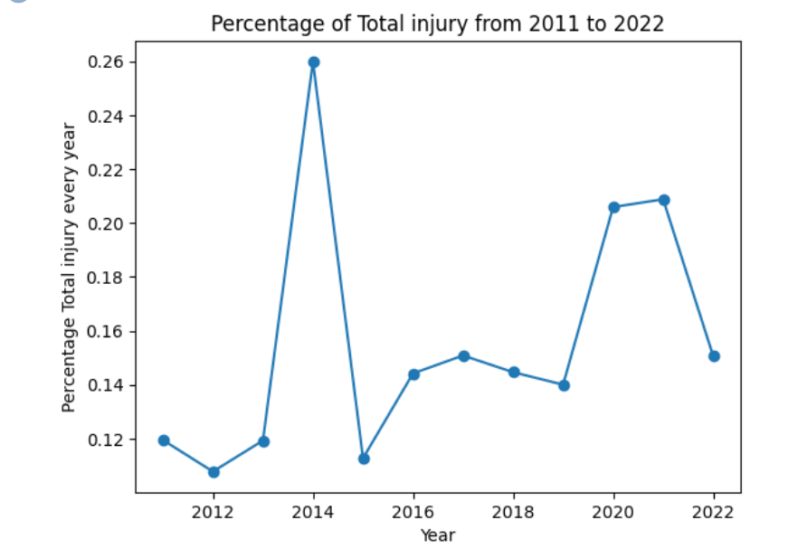

***[Al Mbaye]***

* Analyzed total spending by categories
* Analyzed average spending by categories
* Visualized and compared total spending by category
* Visualized and compared average spending by category

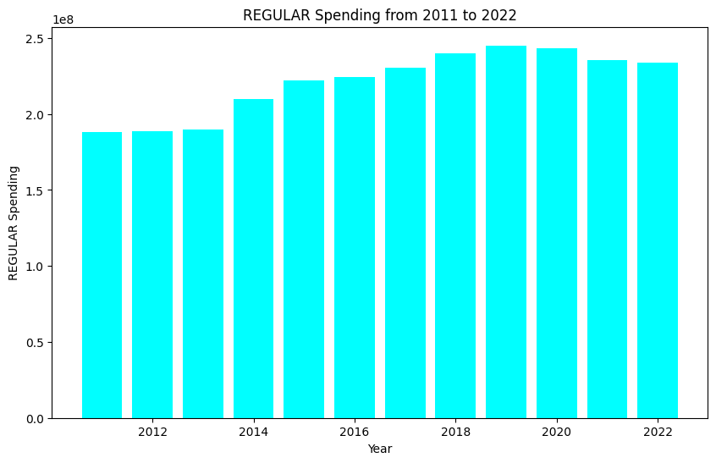

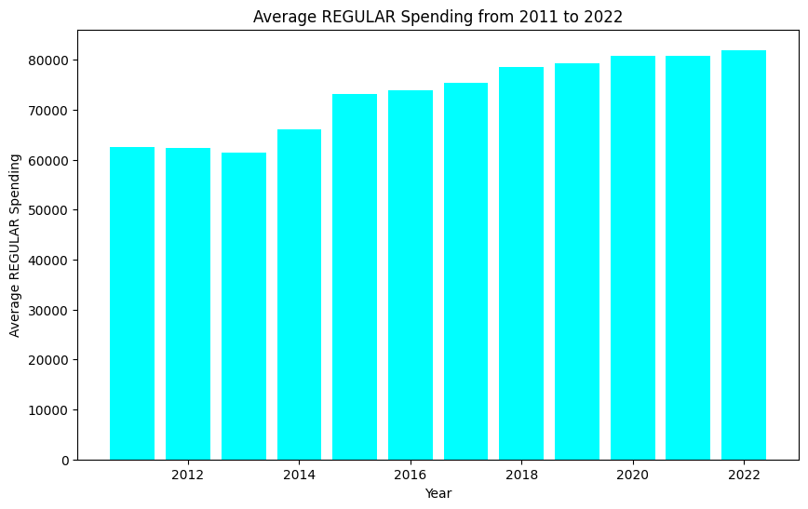

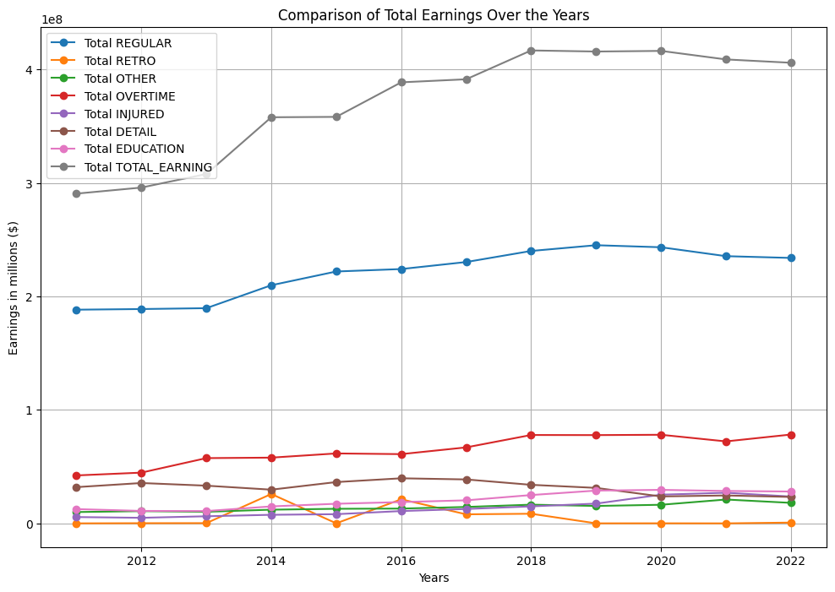

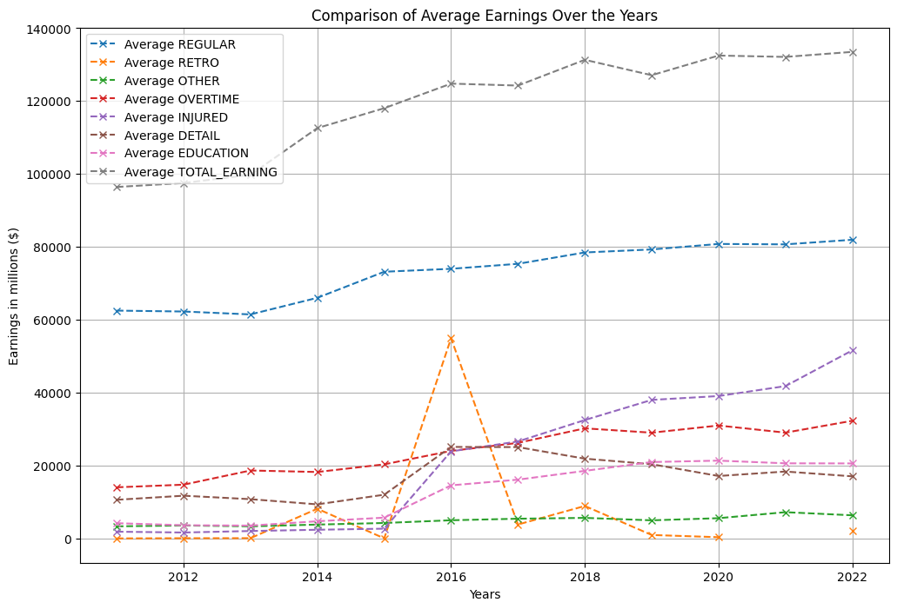

**3. Issues or blockers:**

* Cleaning up the data took a lot of time and effort, primarily because the provided datasets did not adhere to a consistent template (i.e: different columns’ names, values types, column orderings for different years, etc.)
* When investigating police earnings categorized by demographic characteristics, we need to approach this analysis with sensitivity and ensure that any conclusions drawn are based on statistical evidence rather than assumptions. We also need to consider factors that may influence the results, such as department policies, geographic location, or specific job roles.

**4. Plans for next week**

[Bulleted list of the main things you plan to accomplish next week as an individual]

* Analyze the discovered topics in a deeper level and detailed exploration
* Analyze the earnings by pay range (how many % of officers' pay range is from $50k-$70k, $70k - $100k, $100k-$200k, >$200k). Compare this % with the average pay range of other states.
* Connect the dots, try to understand what are the insights that the data conveys
* Explore and analyze new datasets from the provided resources
* Investigate whether certain demographic characteristics such as age, gender, race, tenure and rank influence the worked-to-paid ratios of police officers. This can shed light on potential disparities in compensation within the force